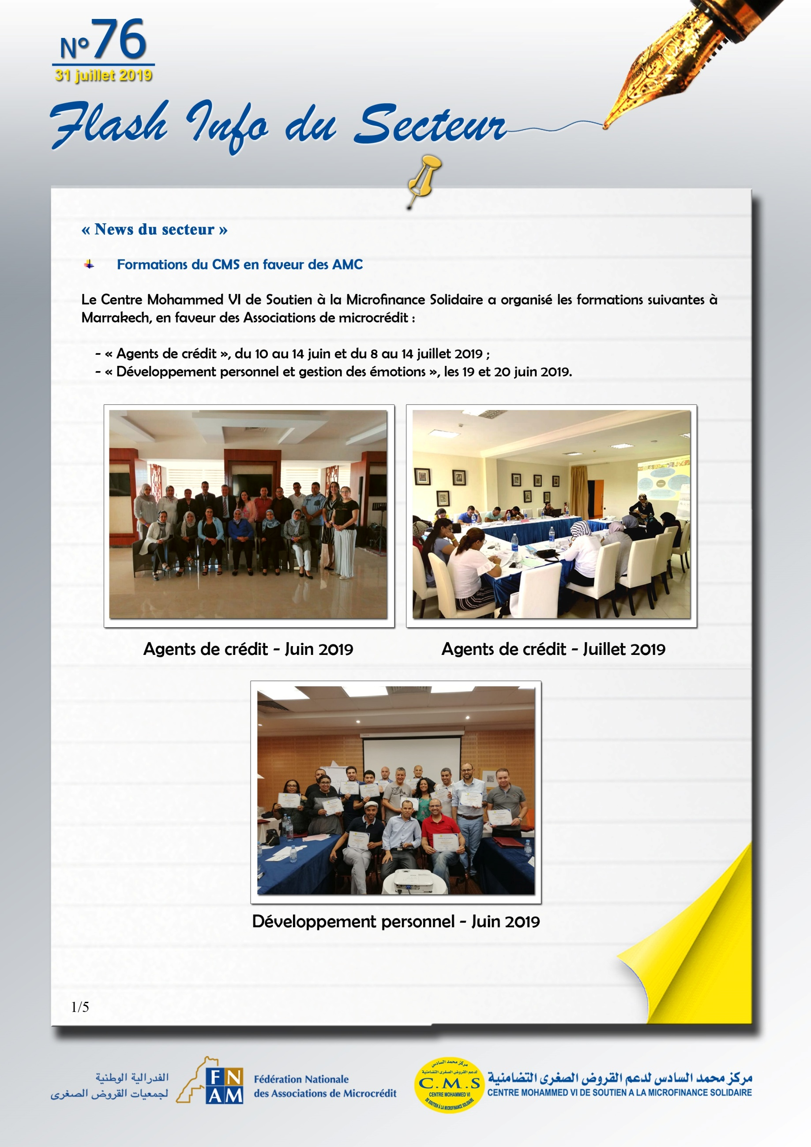

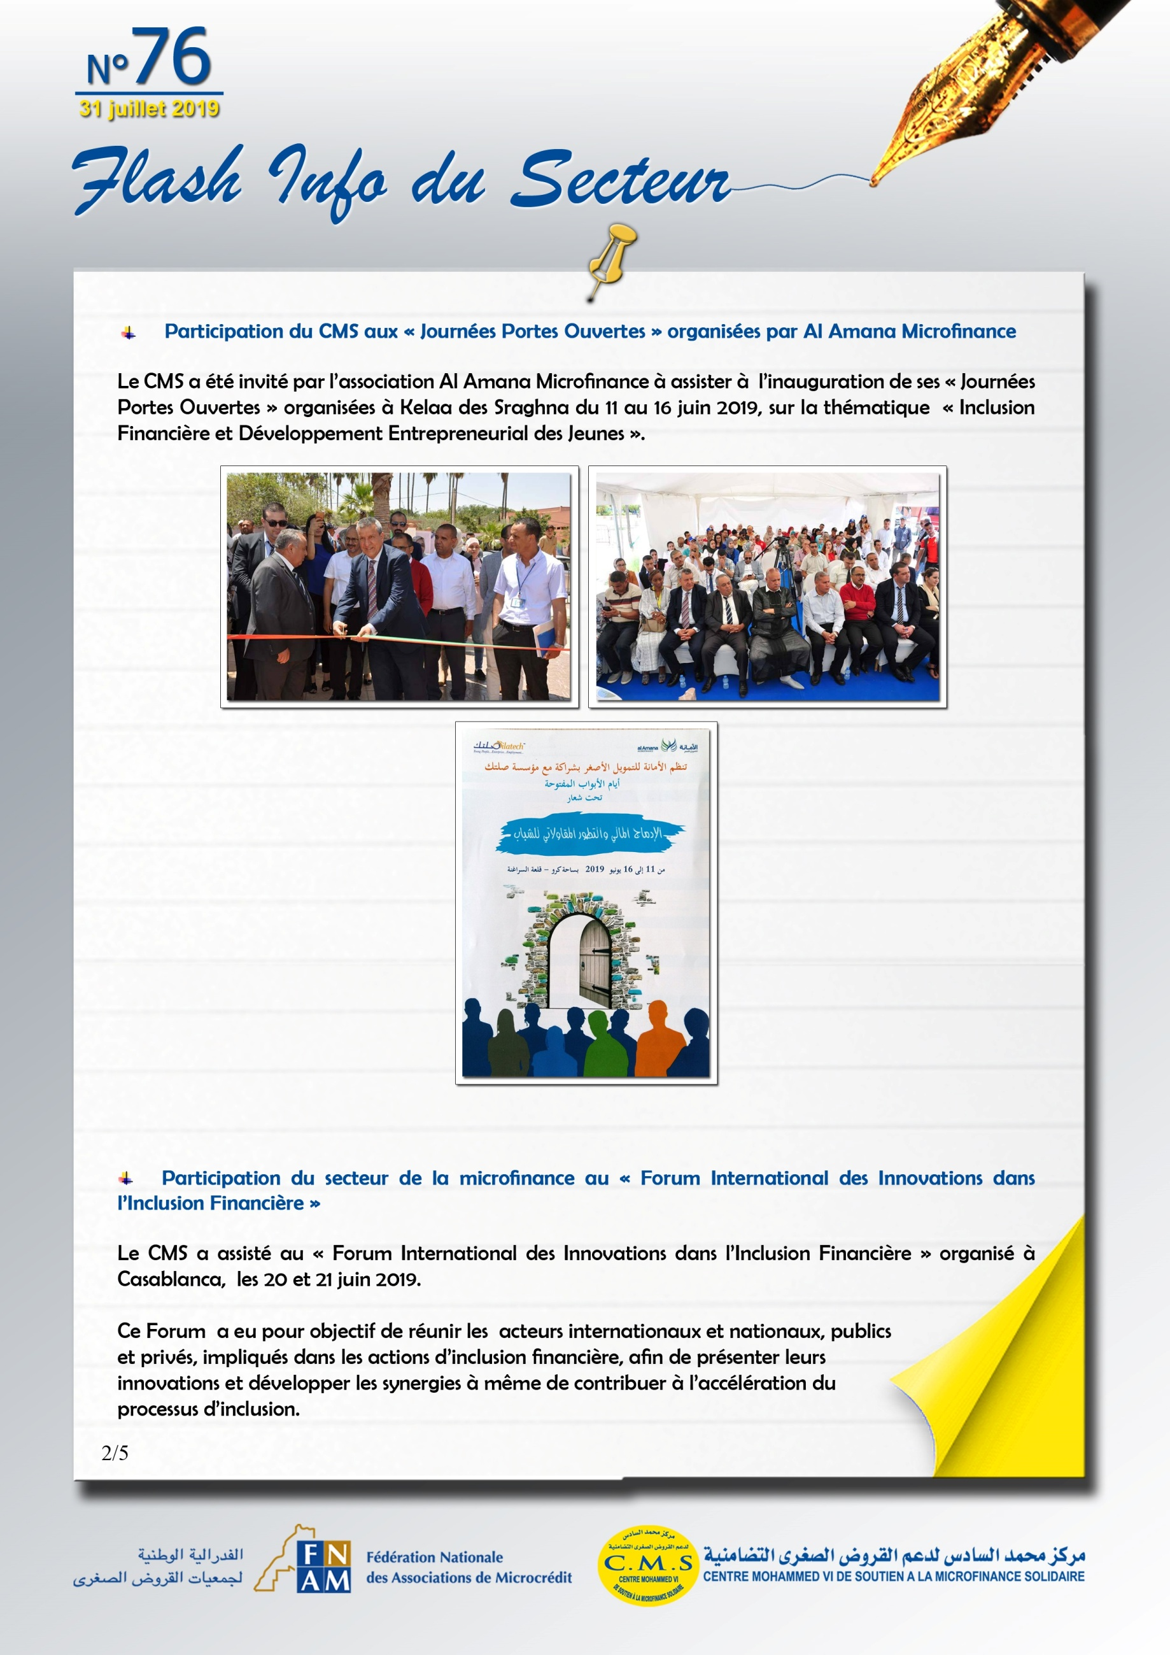



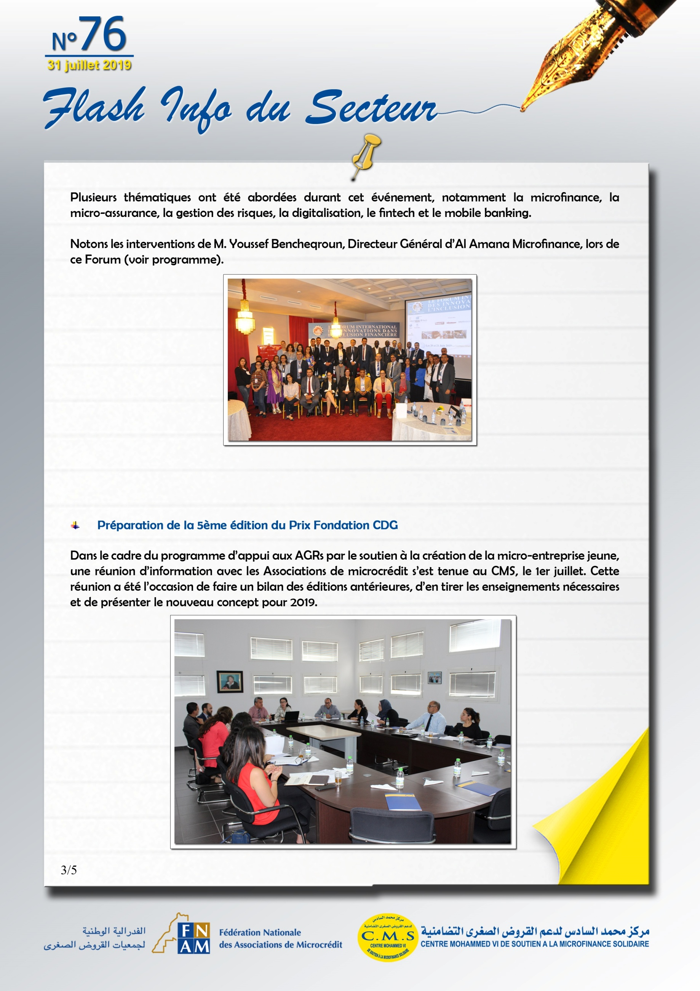



<http://inclusion-financiere.com>

<https://fnh.ma/article/bourse-finances/inclusion-financiere-la-technologie-comme-catalyseur>

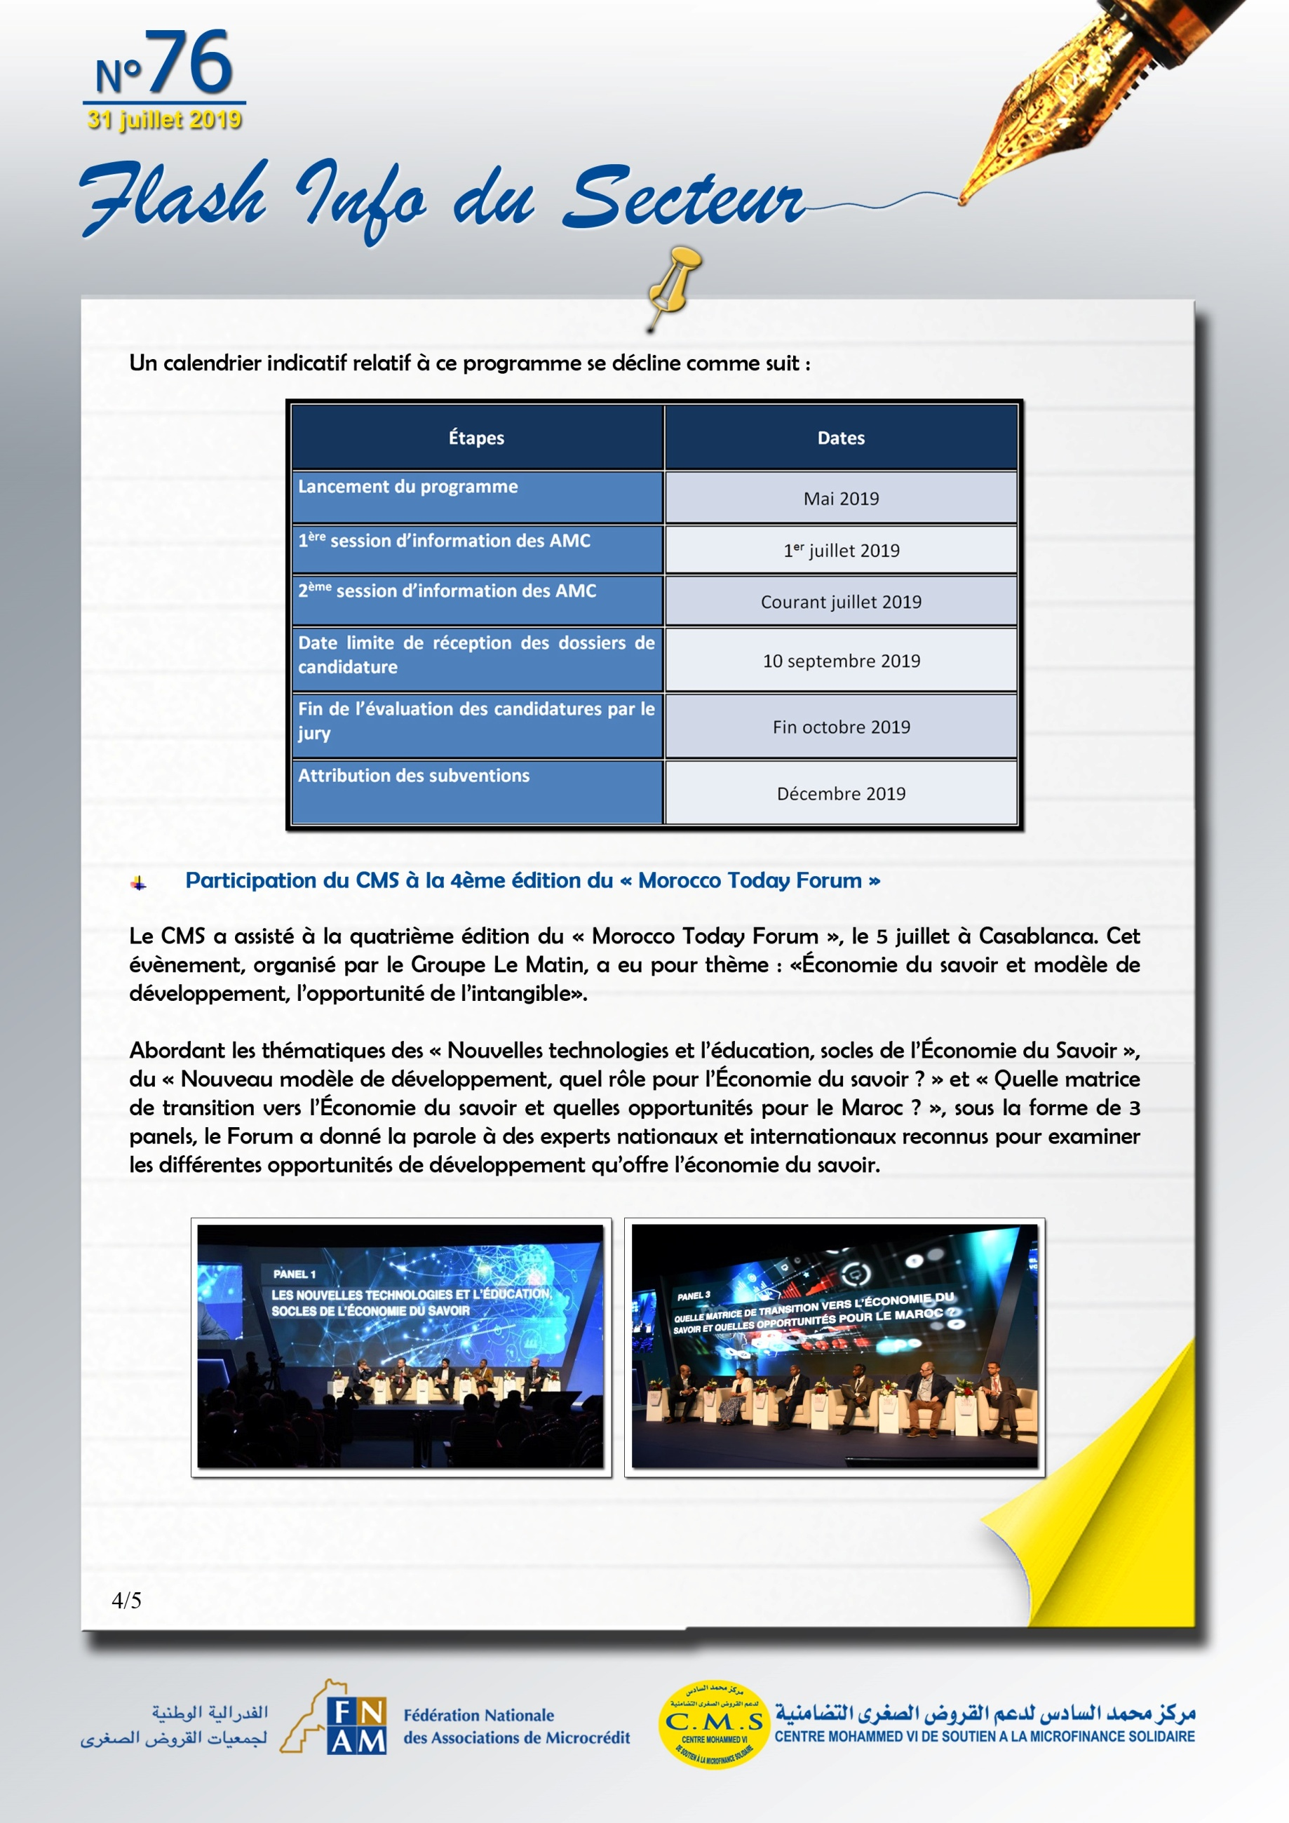

<https://lematin.ma/journal/2019/4e-edition-morocco-today-forum-evalue-place-leconomie-savoir-nouveau-mode-developpement/319027.html>

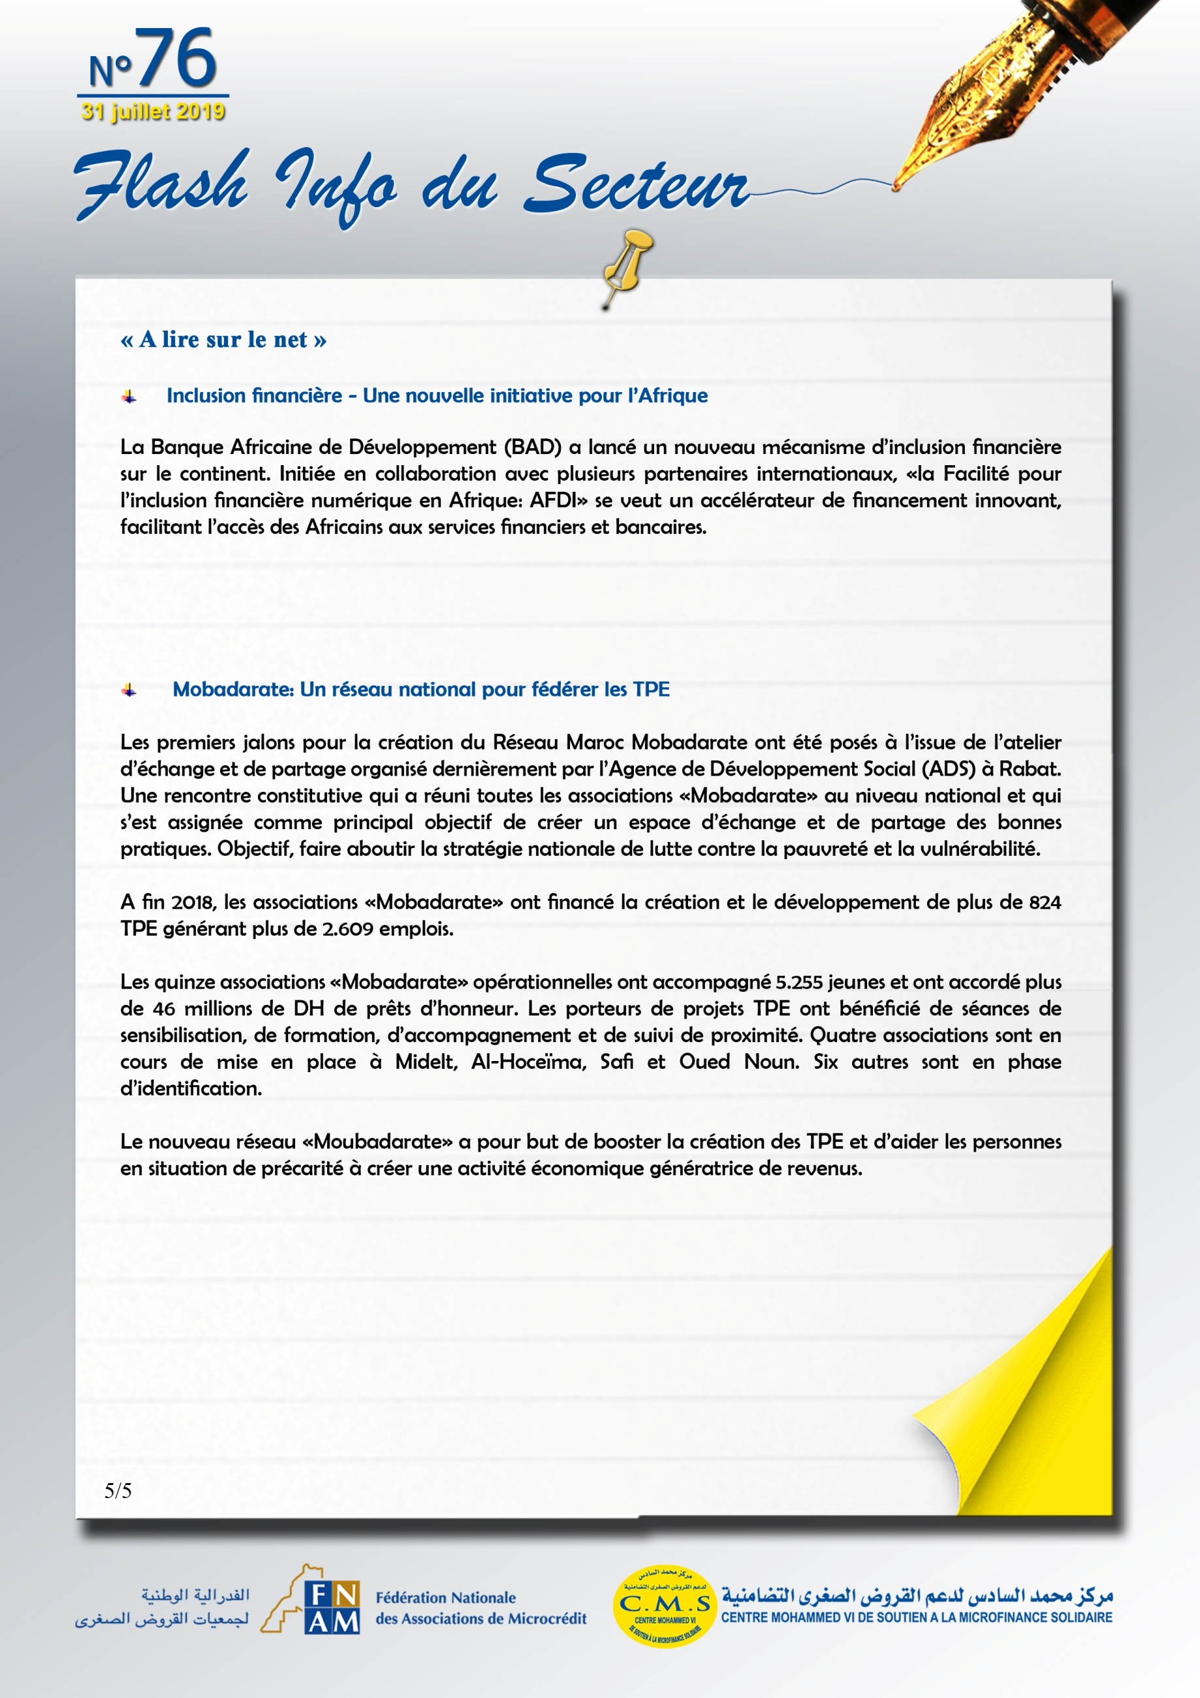

<https://www.leconomiste.com/article/1047473-mobadarate-un-reseau-national-pour-federer-les-tpe>

<https://lematin.ma/journal/2019/nouvelle-initiative-lafrique/317475.html>

<https://www.agenceecofin.com/economie/1206-66869-la-bad-lance-un-nouveau-vehicule-de-financement-destine-a-l-inclusion-financiere-en-afrique>