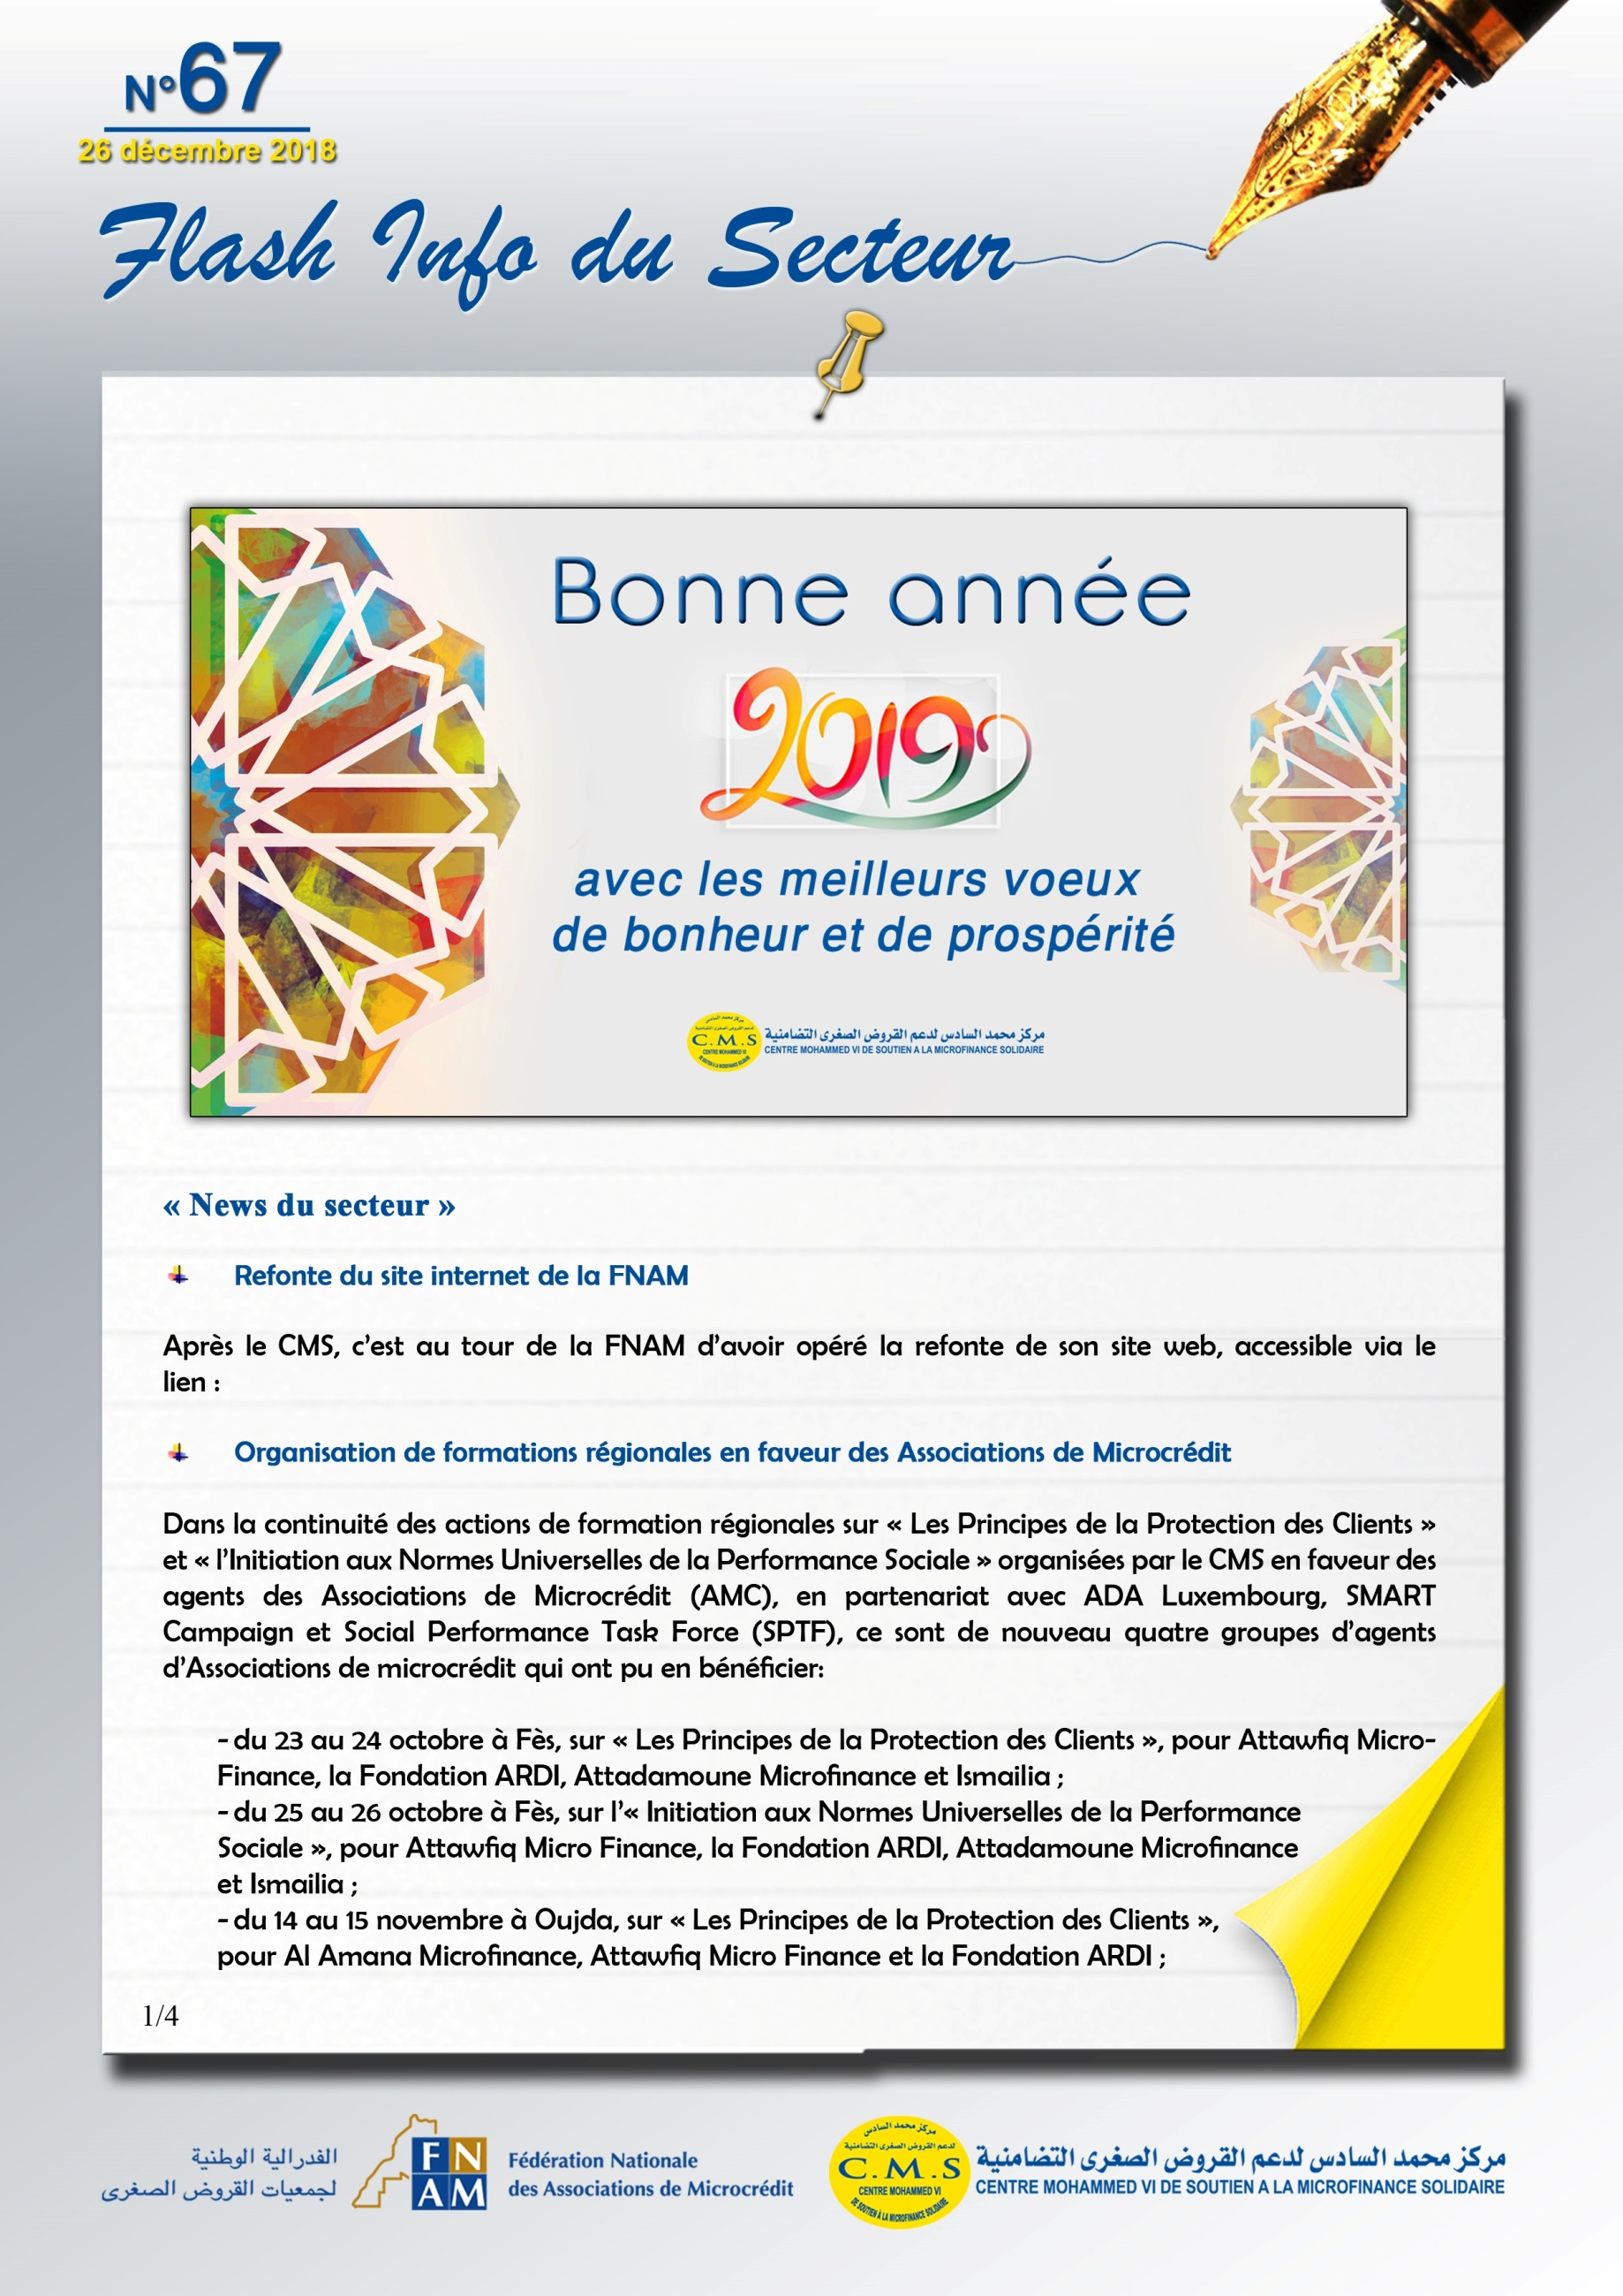
www.fnam.co.ma

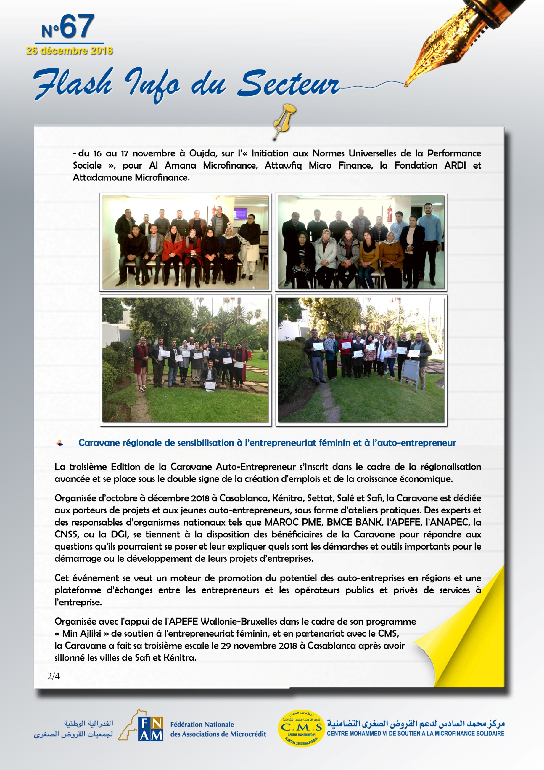

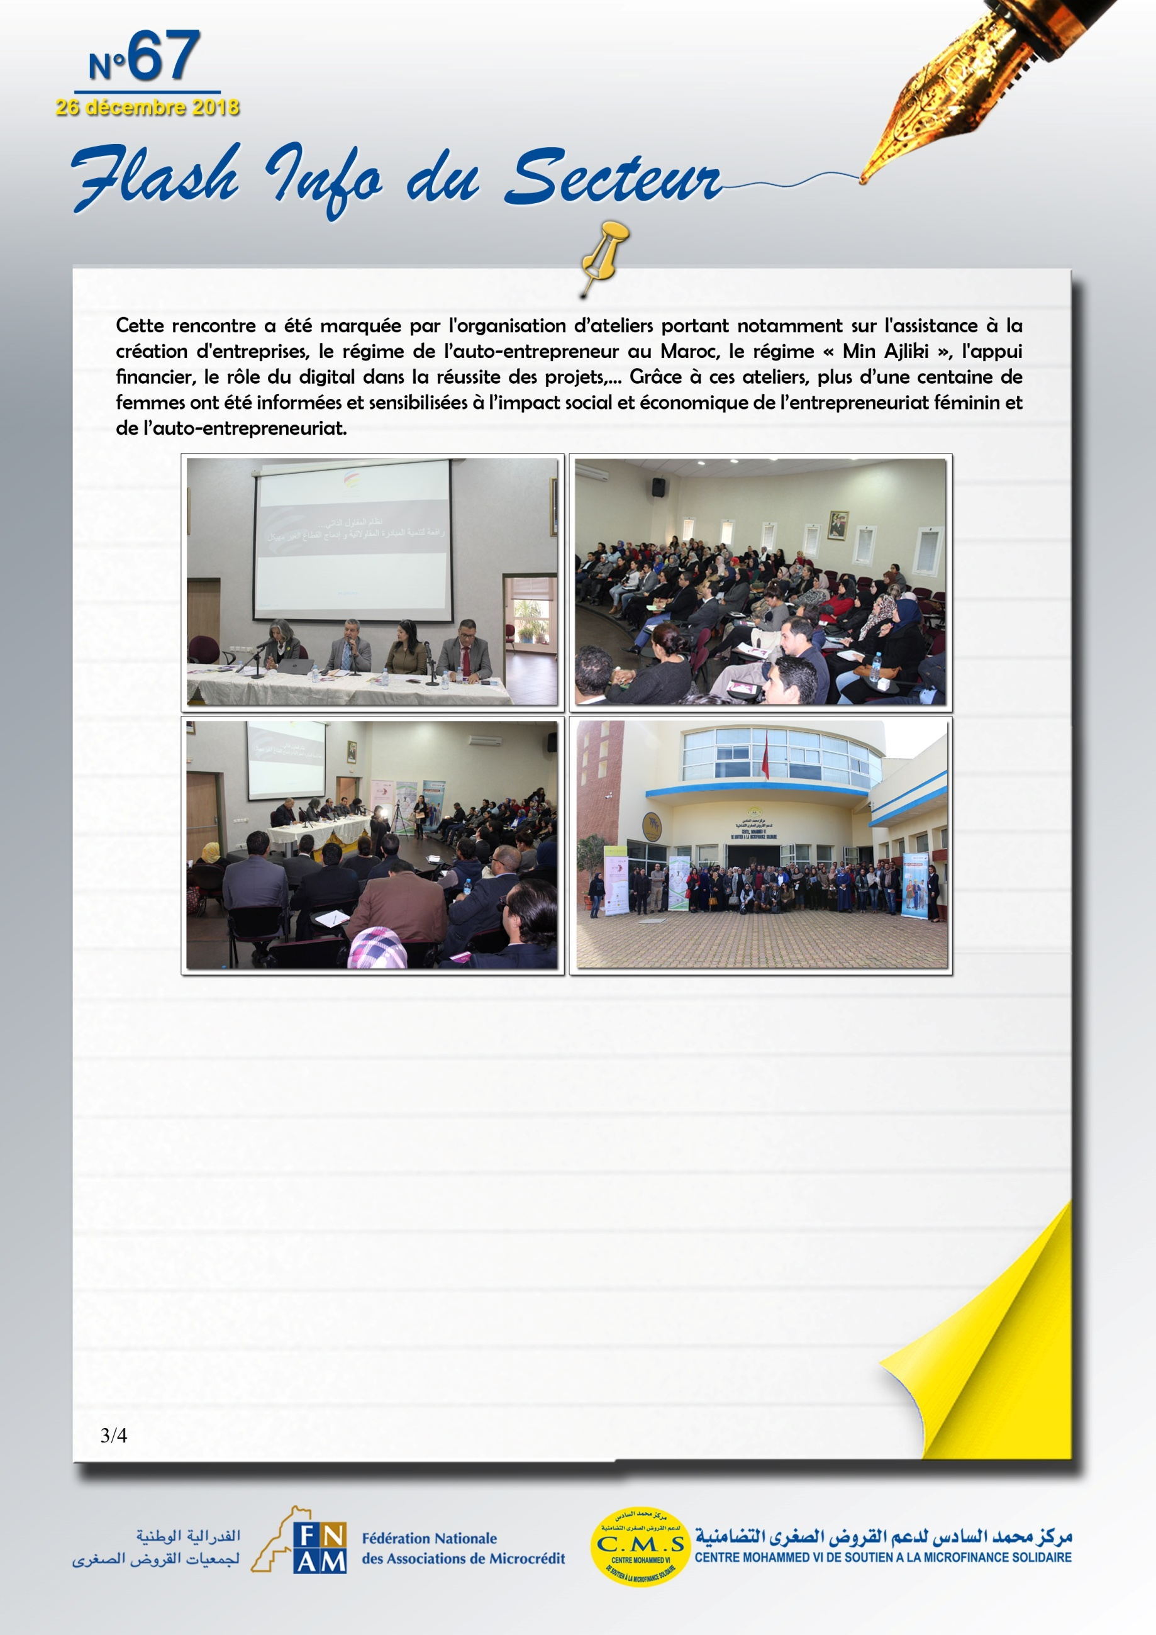
https://lematin.ma/journal/2018/casablanca-accueille-caravane-regionale-sensibilisation-lentrepreneuriat/305867.html?fbclid=IwAR2imuW2HF5ATT9bzM1syUYZcPIKK8m_ydRT4A_bpMt1L-pcaqT_uUJ9wRQ
https://assahraa.ma/web/2018/143883

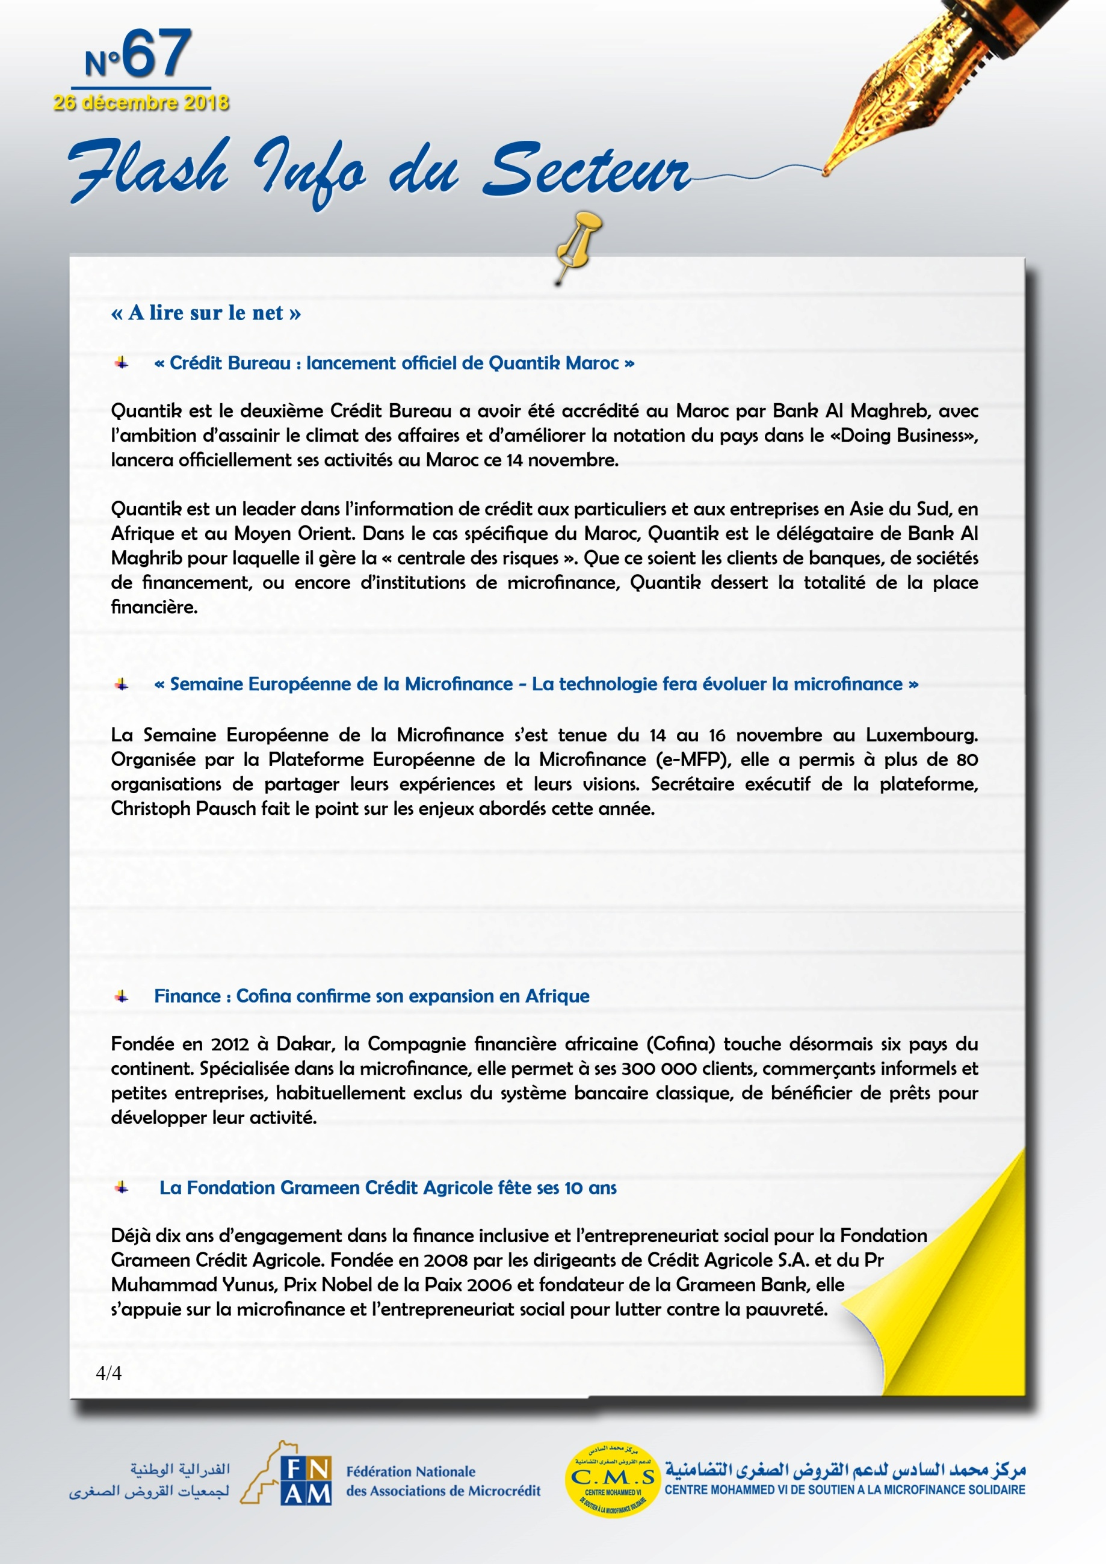
https://www.ecoactu.ma/credit-bureau-lancement-officiel-de-quantik-maroc/

http://paperjam.lu/news/la-technologie-fera-evoluer-la-microfinance
http://paperjam.lu/event/european-microfinance-week-0
http://paperjam.lu/news/advans-recompensee-a-la-semaine-de-la-microfinance
https://www.rti.ci/info/economie/23524/une-institution-ivoirienne-remporte-le-prix-europeen-de-la-microfinance-2018

https://www.jeuneafrique.com/668912/economie/finance-cofina-confirme-son-expansion-en-afrique/

http://www.carenews.com/fr/news/11908-fusac-la-fondation-grameen-credit-agricole-fete-ses-10-ans

