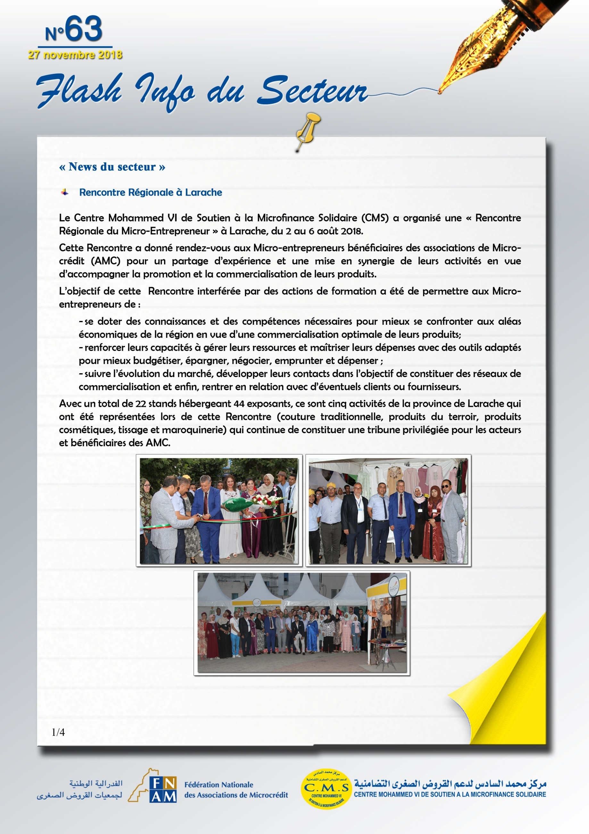

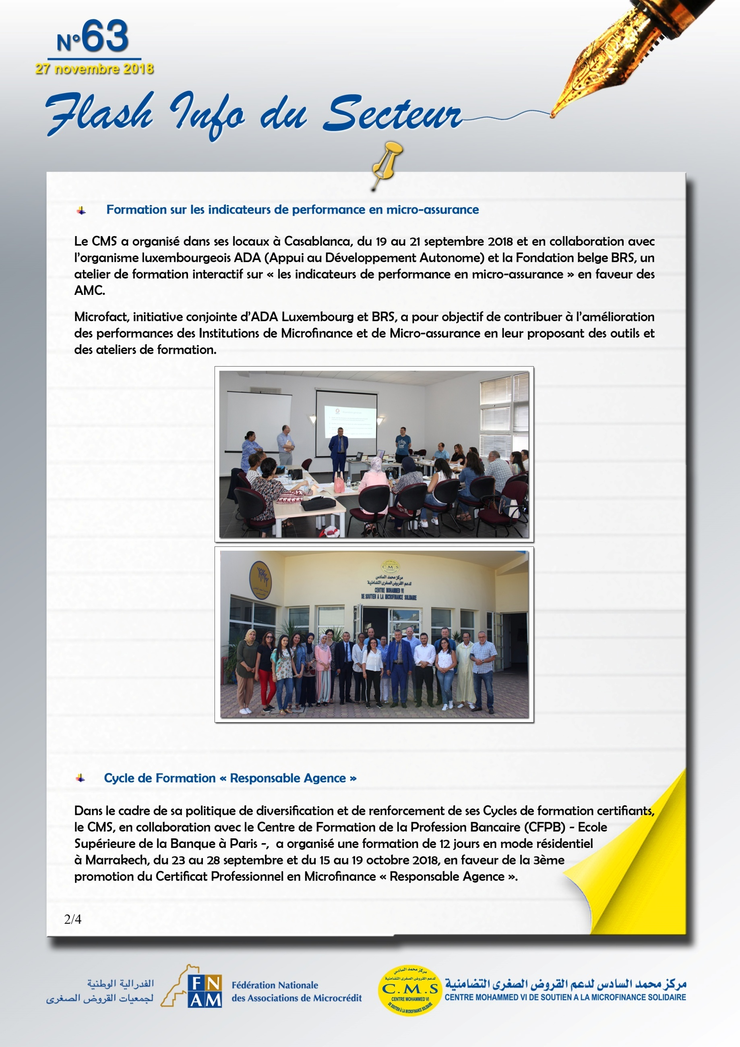
http://www.microfact.org/fr/
http://www.brs.coop/fr/ProjectsInSouth/BRS--Supports/Microfact

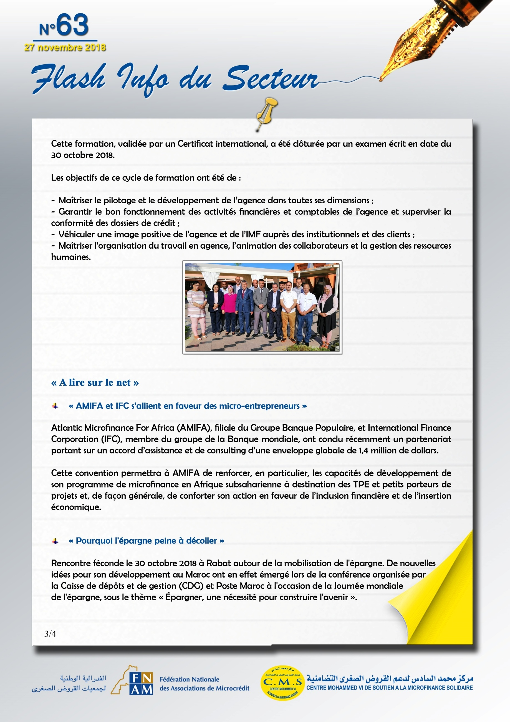
https://www.libe.ma/AMIFA-et-IFC-s-allient-en-faveur-des-microentrepreneurs_a102770.html

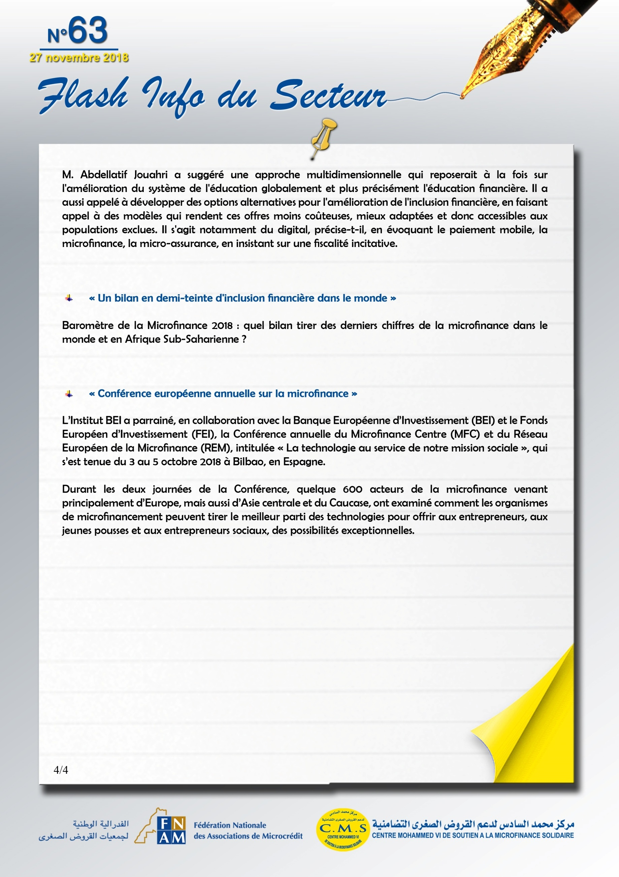
https://lematin.ma/journal/2018/lepargne-peine-decoller/303892.html

https://www.microfinancegateway.org/fr/blog/2018/sept/un-bilan-en-demi-teinte-dinclusion-financi%C3%A8re-dans-le-monde

http://www.eib.org/fr/events/european-microfinance-annual-conference

