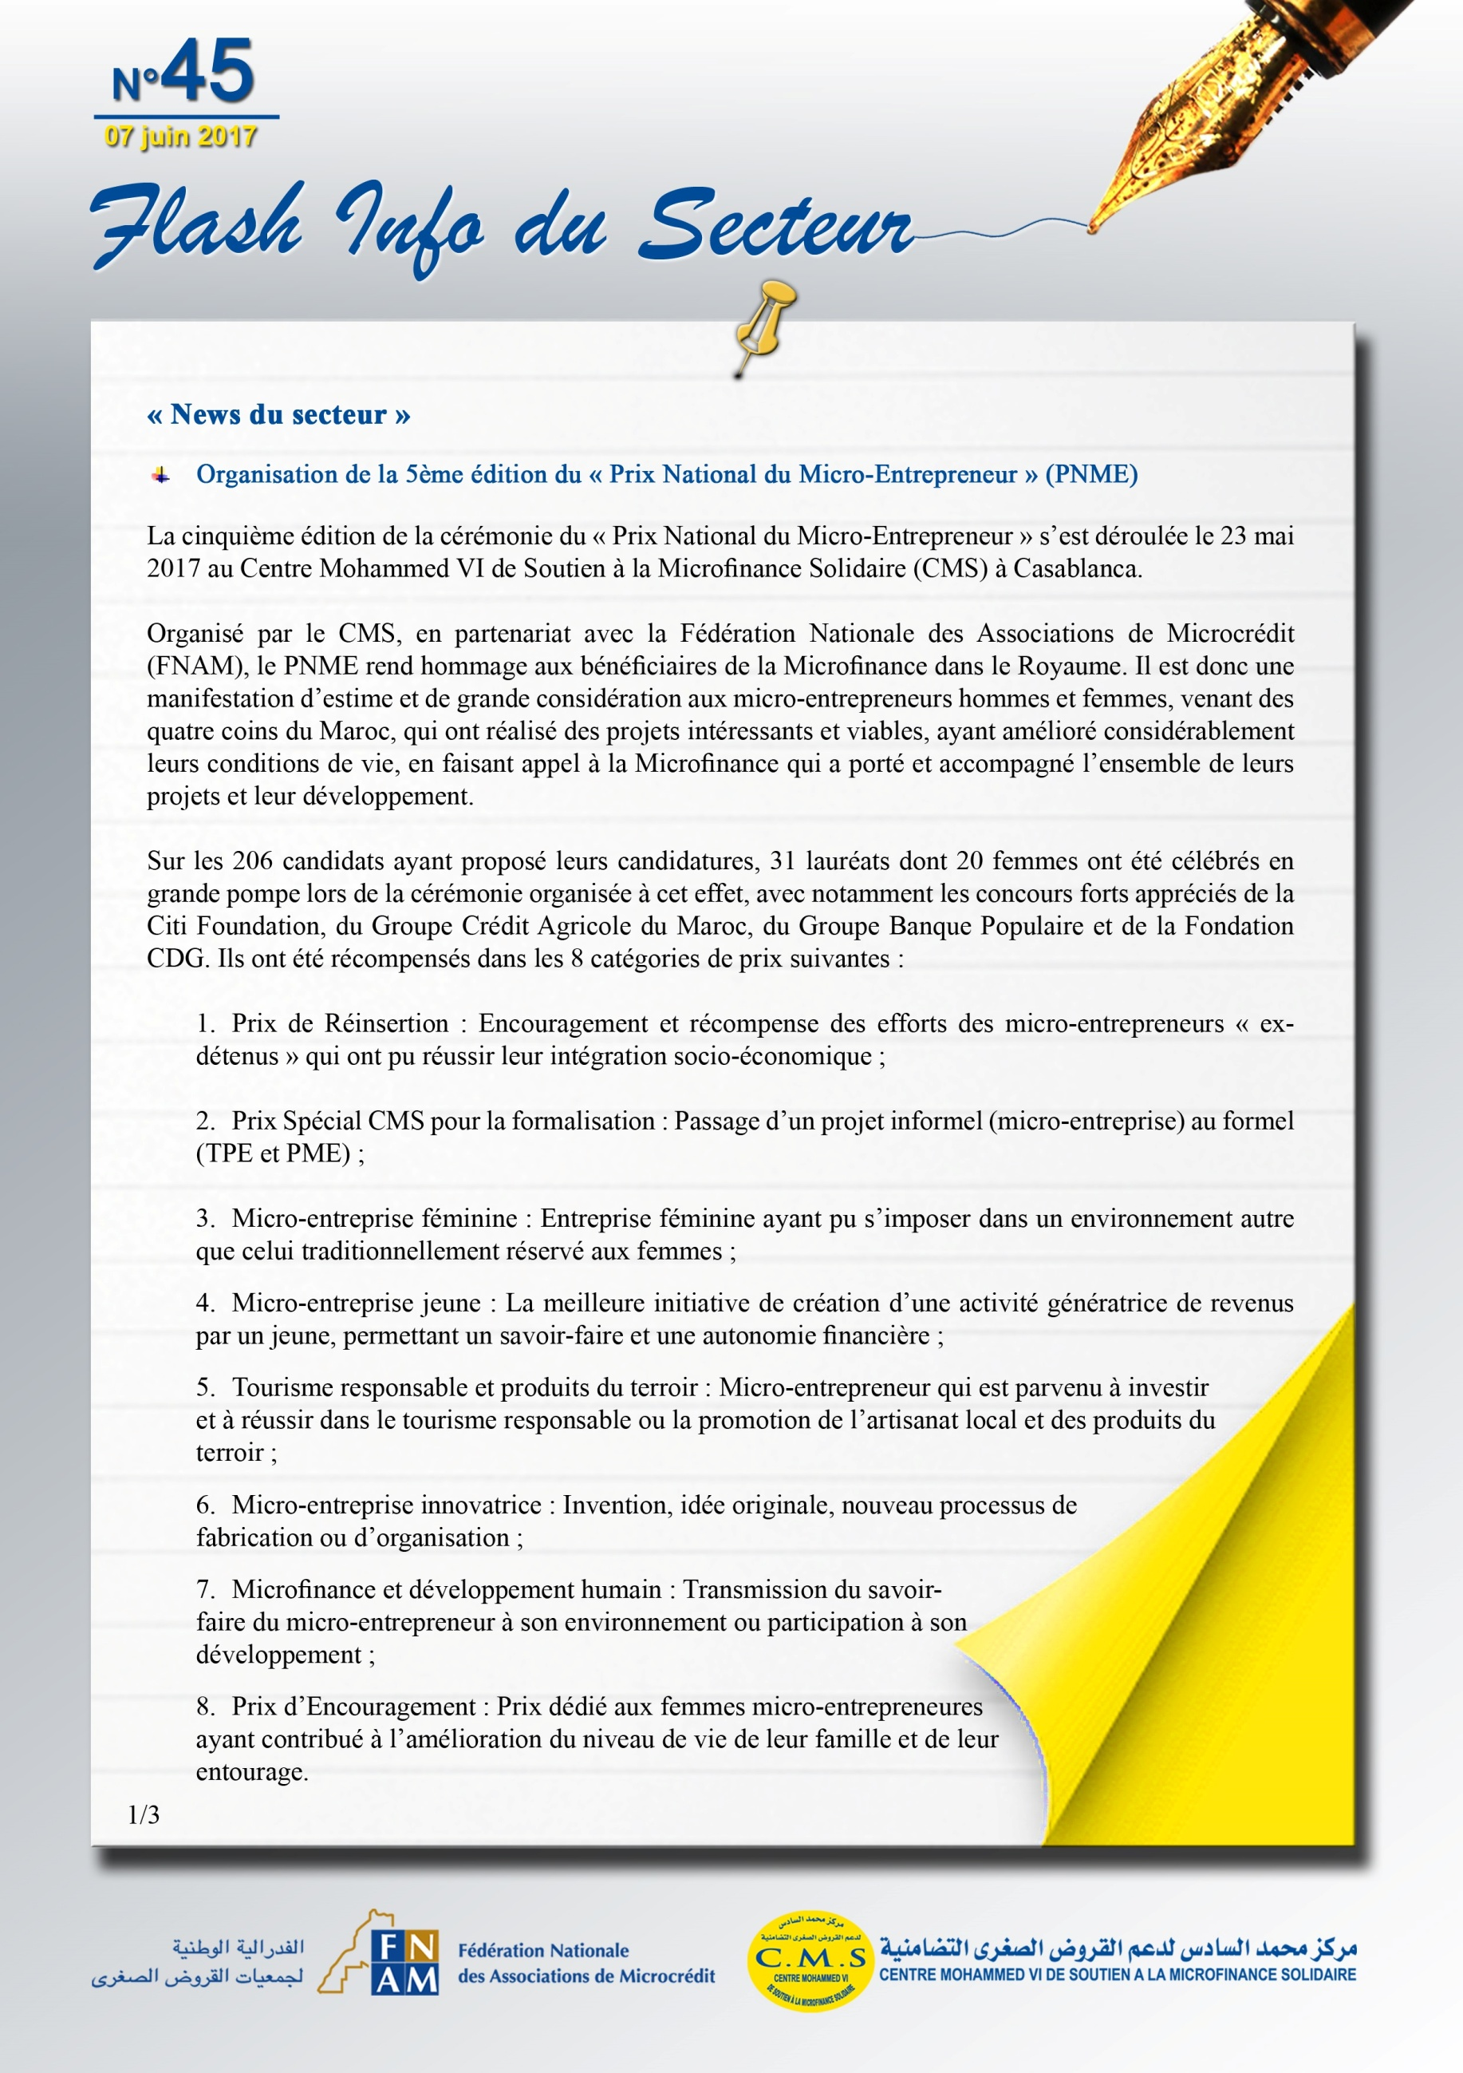

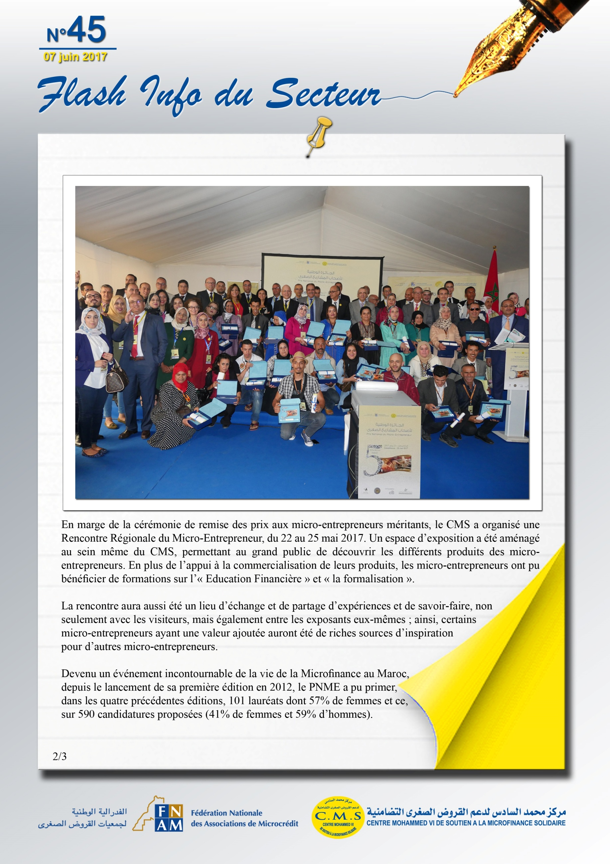

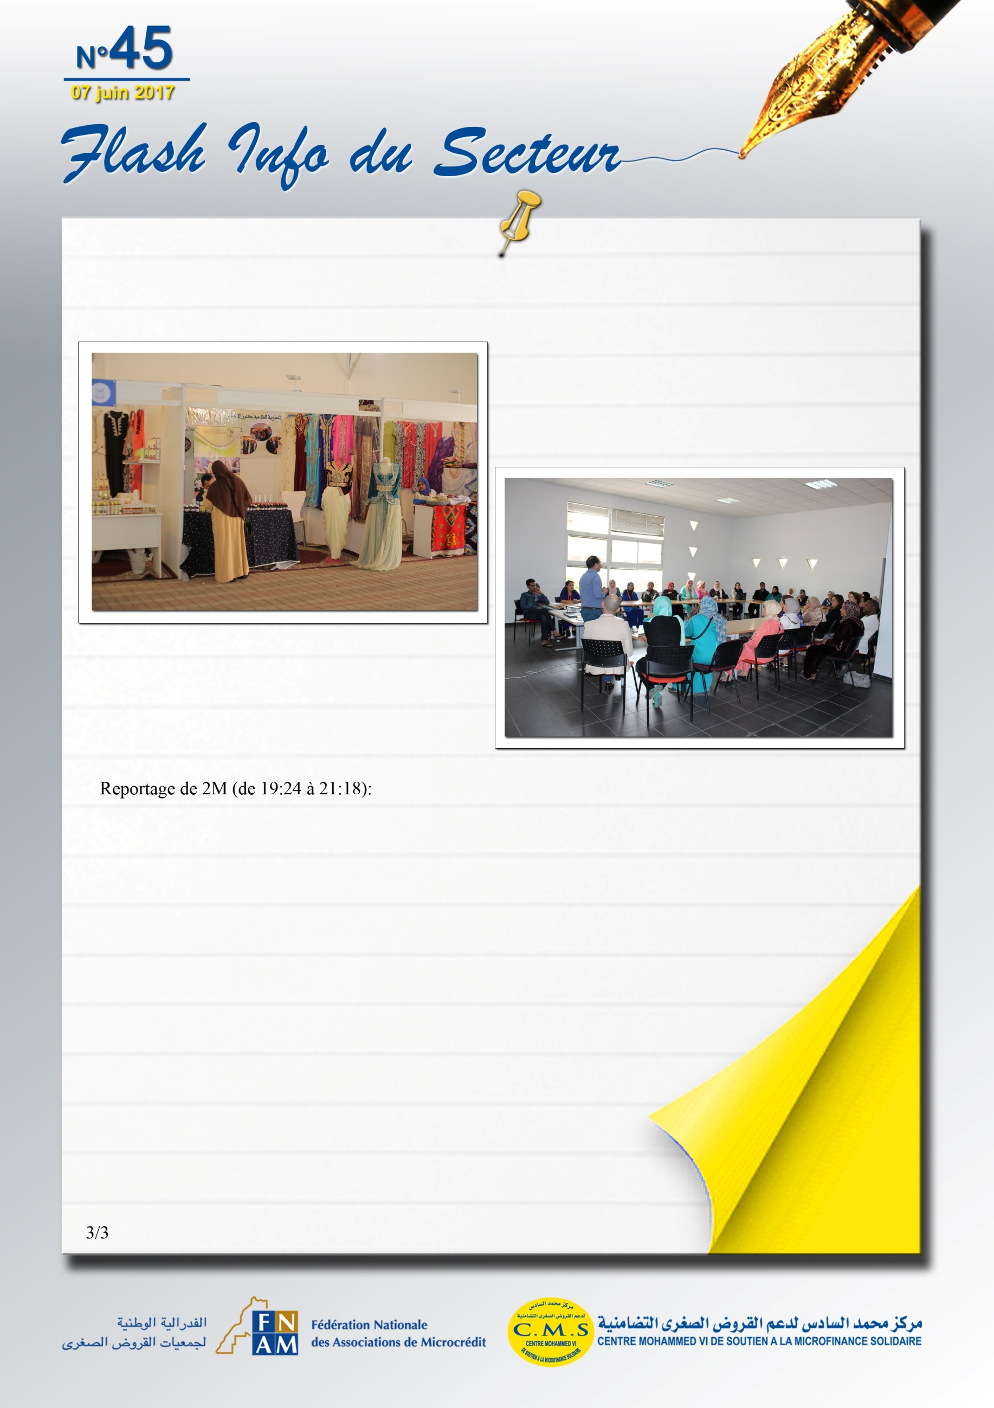
http://2m.ma/ar/replay/home/#!/news/info-soir/info-soir-mercredi-24-mai-1
http://www.mapexpress.ma/actualite/economie-et-finance/5e-prix-national-du-micro-entrepreneur-31-laureats-primes-dont-20-femmes/
http://www.maghrebemergent.info/actualite/breves/fil-maghreb/73766-maroc-5e-prix-national-du-micro-entrepreneur-31-laureats-primes-dont-20-femmes.html
http://aujourdhui.ma/economie/31-laureats-primes-au-5e-prix-national-du-micro-entrepreneur
http://lematin.ma/express/2017/31-personnes-recompensees-a-la-cinquieme-edition/272458.html
http://lematin.ma/journal/2017/31-laureats-recoivent-le-prix-national-du-micro-entrepreneur/272657.html
https://arabic.cnn.com/business/2017/05/24/small-projects-mrocco

