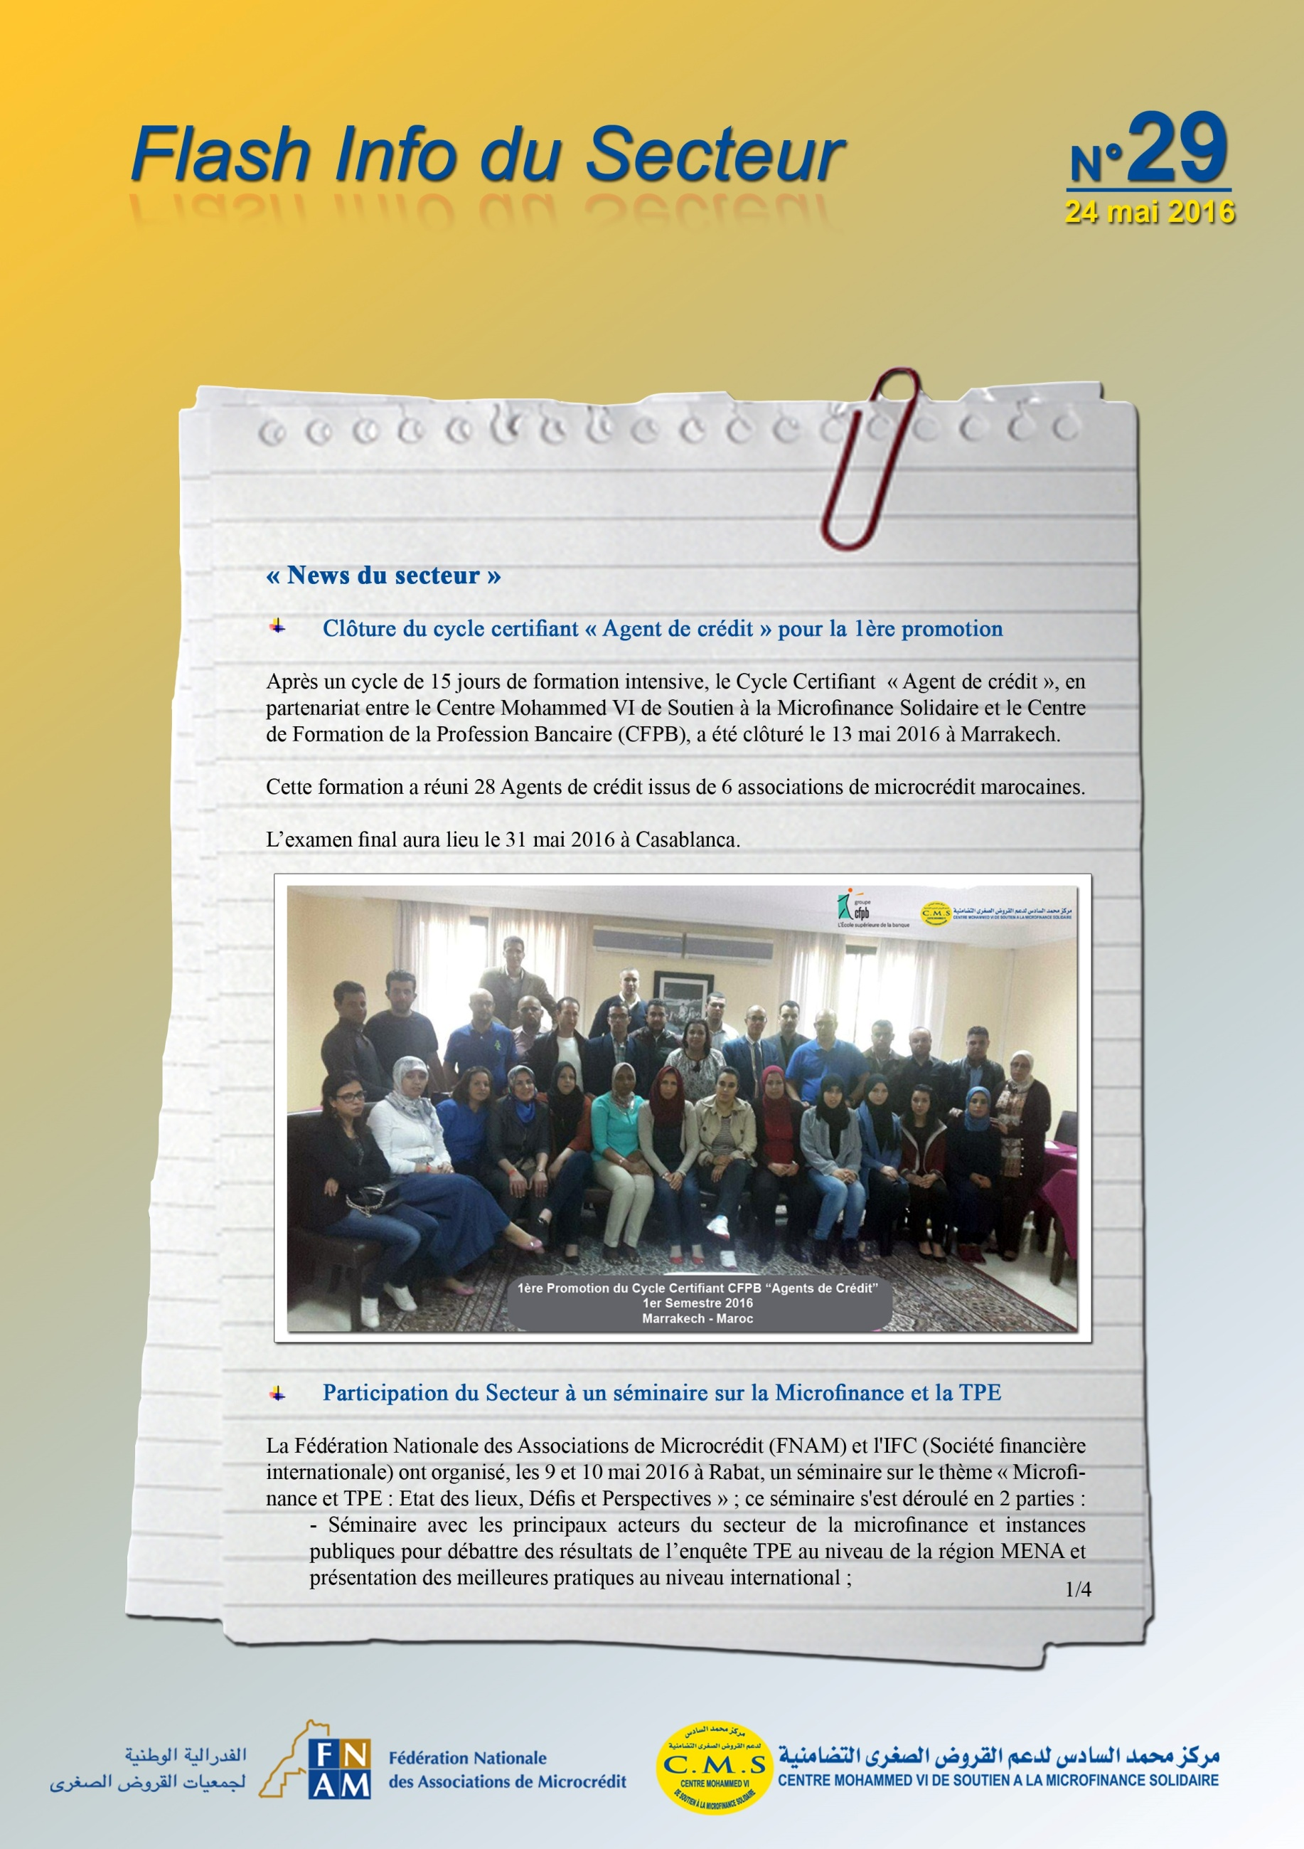

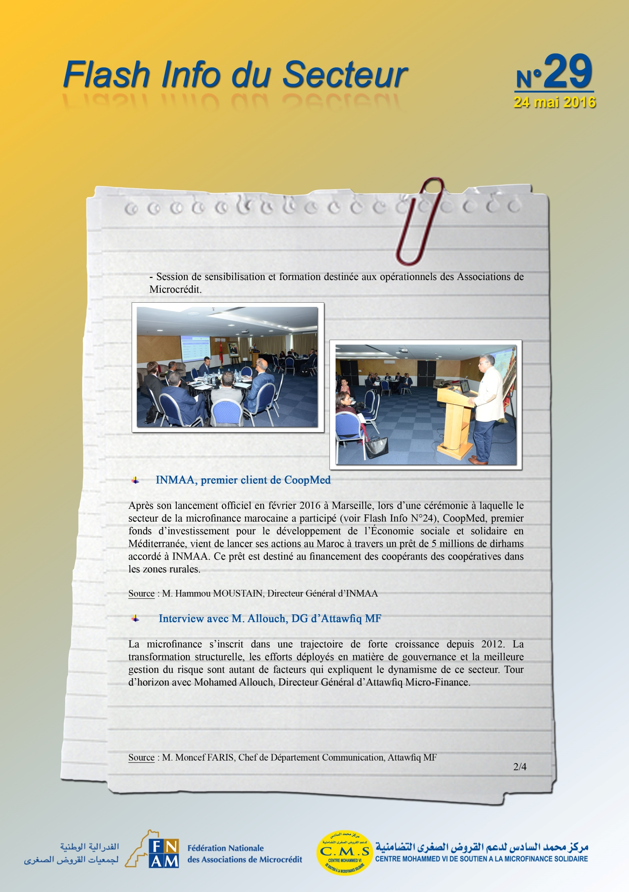

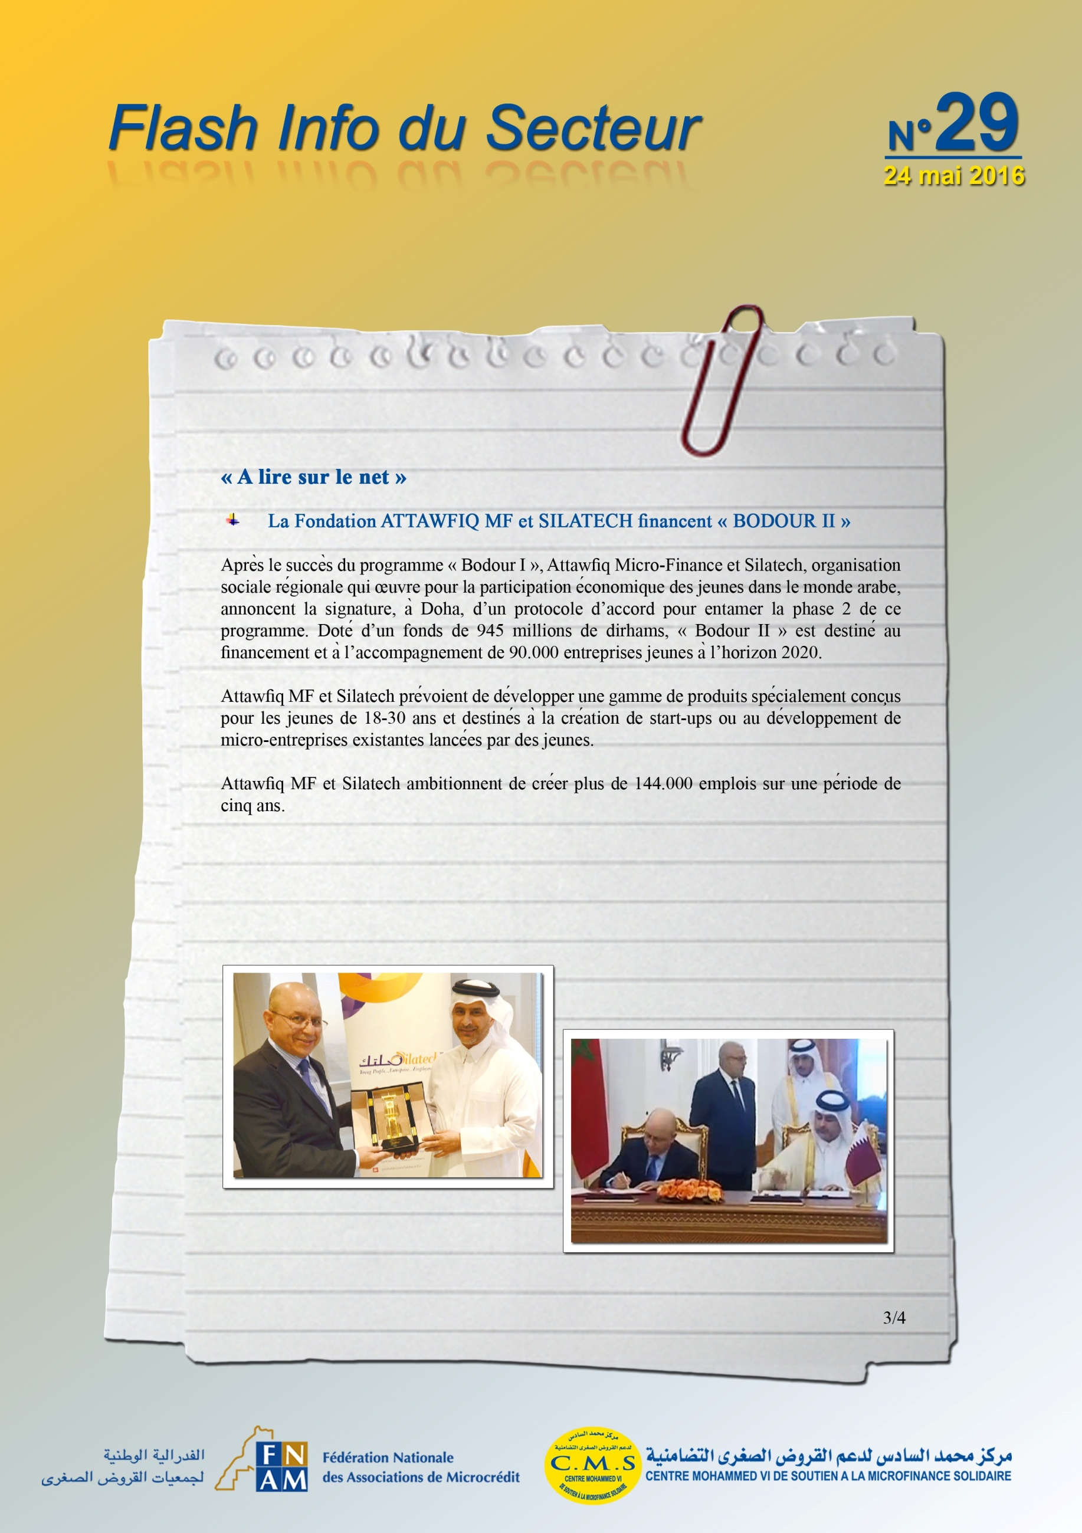
http://lnt.ma/le-groupe-banque-populaire-et-silatech-financent-bodour-ii/

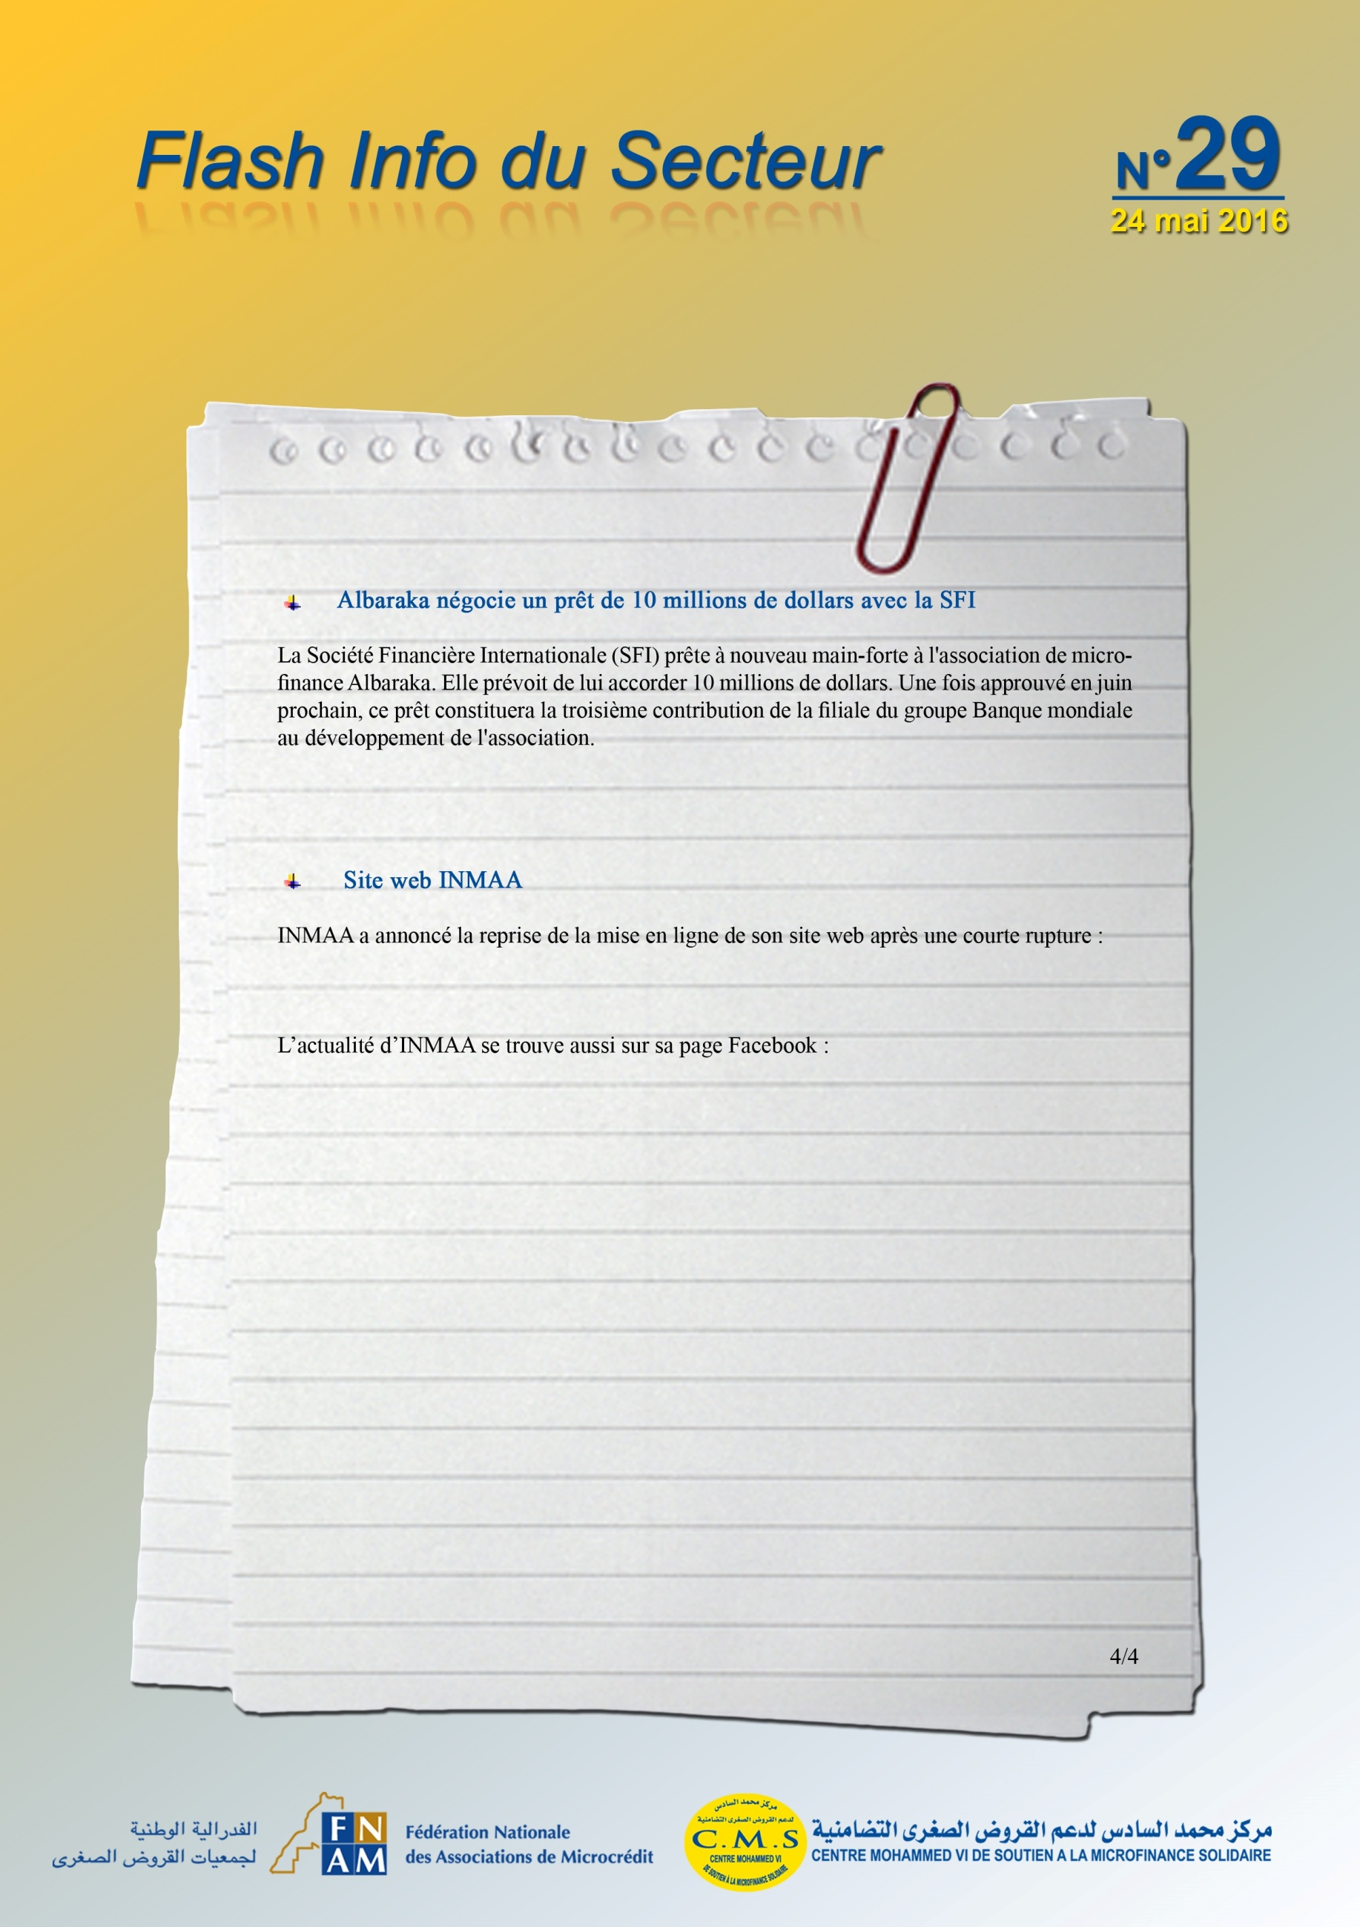
http://lematin.ma/journal/2016/albaraka-negocie-un-pret-de-10-millions--de-dollars-avec-la-sfi/247324.html

www.inmaa.ma
https://www.facebook.com/INMAAmaroc

